MIDTERM EXAMINATION
TIME ALLOWED: 90’
Subject: Linear Algebra.
No Book and Laptop allowed

1/ a/ Solve the equation 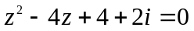.
b/ Compute 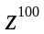, given that 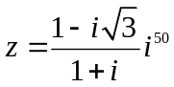.

2/ Find the matrix X such that 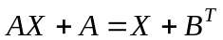, given that
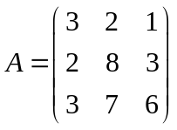, 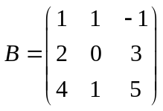.

3/ Determine all real value(s) m, such that the matrix

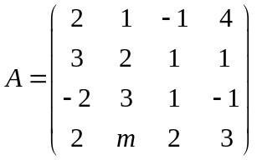 is invertible.

4/ Solve the following system of linear equations
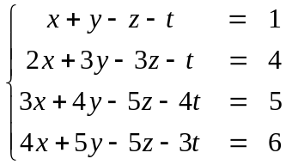

5/ a/ Find the set of values of k for which the following system of equations has no solution
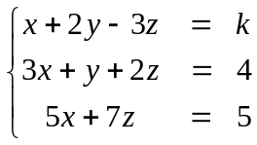
b/ Describe the geometrical relationship of the three planes represented by this system of equations.

6/ Determine all value(s) m such that the set is the spanning set for 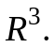

7/ Let 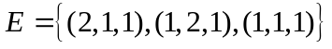 and 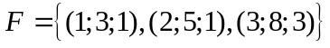be two bases for 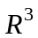.
Find the coordinates of the vector with respect to 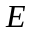,given that 

